Cash Forecast UI:
Overview:
- The Cash Forecast will be a new tab within the main navigation of the Aloha platform, appearing immediately after the Overview tab.
- This feature will provide users with a centralized interface to view, analyze, and simulate cash flow forecasts using a combination of historical data, user input, and hypothetical future flows.^{[1]}
- Please make a second tab after Overview called “Cash Forecast:

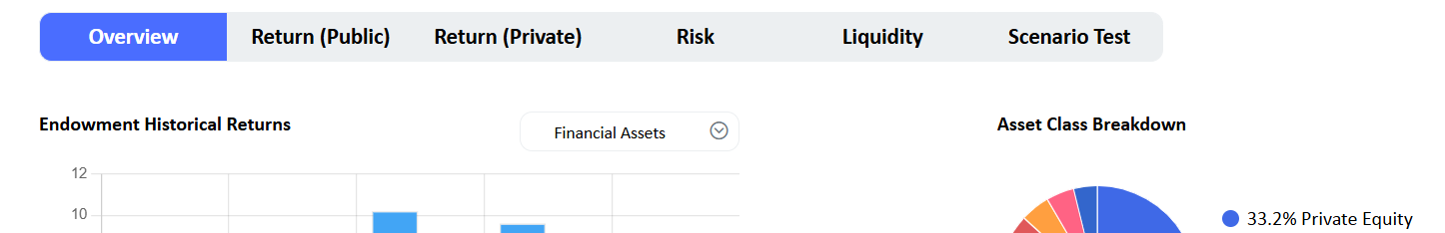

Primary Navigation Structure
The Cash Forecast section consists of four main sub-tabs:
- Dashboard (Main Tab)
- Historical
- Details
- Liquidity Dashboard
Each sub-tab offers tailored functionality as detailed below.

Dashboard Tab:
Core Features
- Forecast Parameters Button

- Users can open a modal or sidebar panel to configure the following parameters, which drive the forecast model:
- Illiquid Pacing Method (choose between):
    - Last 3 months historical pacing
    - Last 12 months historical pacing
    - Manual Pacing:
      - If user selects manual pacing, additional metrics are to be populated:
        - Annual Estimated Distribution (%). Both will generate a calculated amount that the % means in $ terms
        - Annual Estimated Contribution (%). This will generate a calculated amount which the % means in $ terms
  - Buffer Parameters
    - Minimum Buffer
    - Minimum Notional Buffer (%)

- Summary table of Fixed Income and Cash Amounts: Presents a summarized breakdown of fixed income and cash amounts in a compact table for quick reference.
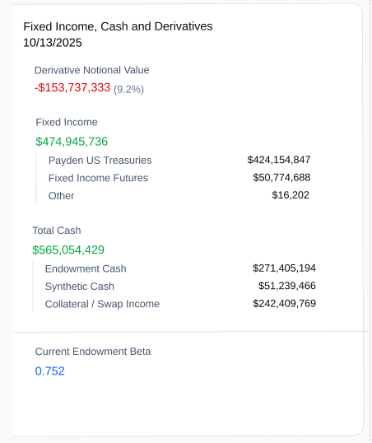
- Graph of the projected balance : Presents a summarized breakdown of fixed income and cash amounts in a compact table for quick reference.
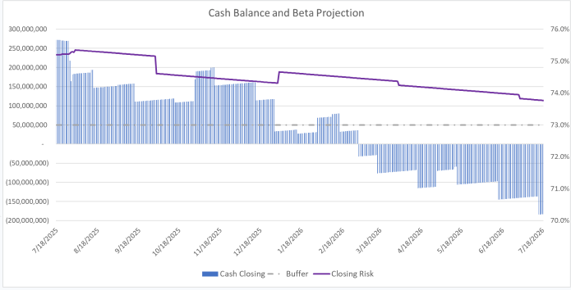

- Hypothetical Flows:
  - Users can add simulated future cash flows, dynamically altering projections.
  - Cash flows can be attributed to current funds (dropdown of Solovis funds, auto-populating beta values), or new funds (user provides beta and other details).
  - Required fields for entry: Fund selection, Effective Date, Cash Date, Amount, Transaction Type
  - Cash flows can be attributed to current funds (dropdown of Solovis funds, auto-populating beta values), or new funds (user provides beta and other details).
  - Toggles to include/exclude individual hypothetical flows in the model.
  - Save/load flow options:
    - "CIO Flows" (Tim's workspace, pre-saved scenarios)
    - "Operations Flows" (Euan's workspace, pre-saved scenarios)
    - User-defined saved flows, which auto-load on page refresh.

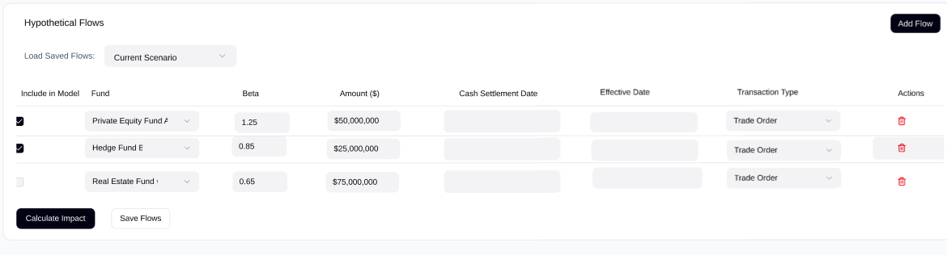
  - "Calculate Impact" button re-runs forecasts, updating charts and outputs immediately.^{[1]}

- Projected Cash Flow Details:
- This section shows more details of the underlying cashflows that are driving the projected cash balance.
- The cash flows will be grouped by month. Users can expand/collapse each month.
  - Expanded view un-collapse and collapse the month to see the daily aggregated cash movements
  - Clicking on any daily value will open a window that shows all the underlying transactions for that day
- This will be a layered drill down which will help users trace high level and granular cash activity
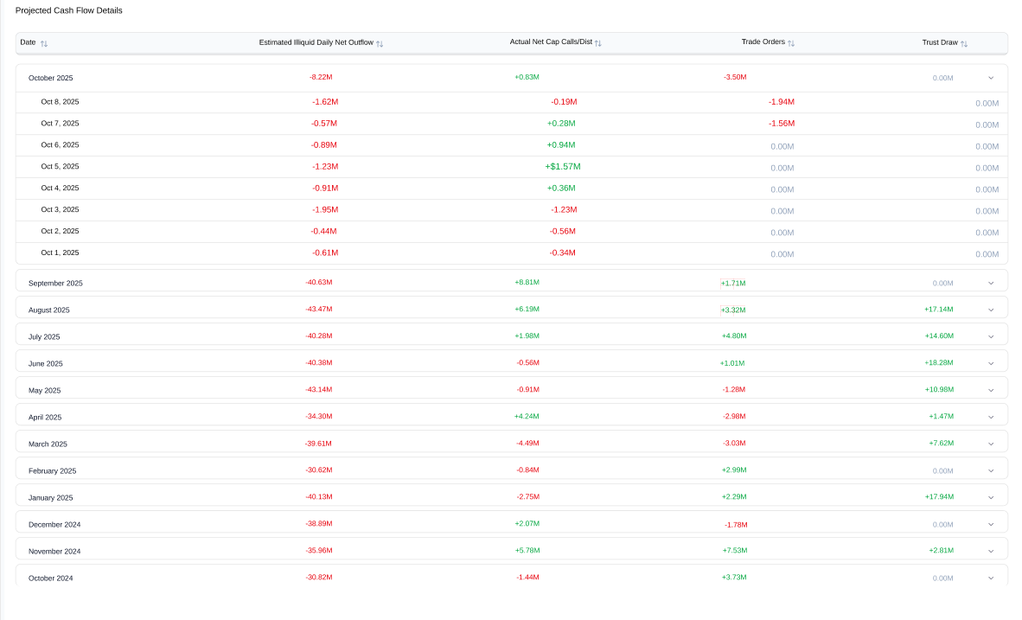

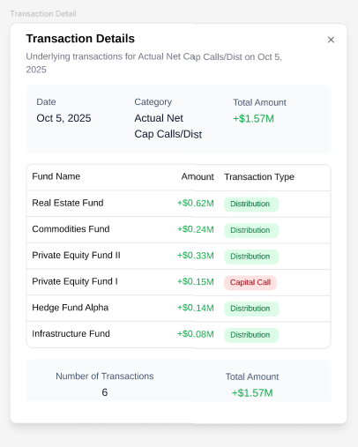

- Other Items:
- All generated forecasts are saved automatically for historically lookup.
- Need the ability to show the Cash balance and Beta Project as it was as of any previous day (restrict to only one month in the past).

Historical Tab:
Core Features
- Users can select a Start Date and End Date to control data shown in two graphs.
  - The start date will be restricted to be month end dates
  - End date will also be restricted to month end dates in addition to “today’s date”
- Net Cash Flow Graph displays aggregated net cash flows for drawdown funds, with month-by-month intervals for periods under 1.5 years and quarterly intervals for periods over 1.5 years.
  - On Top of each bar, show the total net cash flow (adding up all the underlying)
  - When the mouse hovers over the bars, provide the data point and also the underlying components. Net Cash Flow = Distributions – Capital Calls. So if you however over Absolute Return show:
    - AR Net Cash Flow: -60.1
    - AR Capital Calls: 63.6
    - AR Distributions”3.5
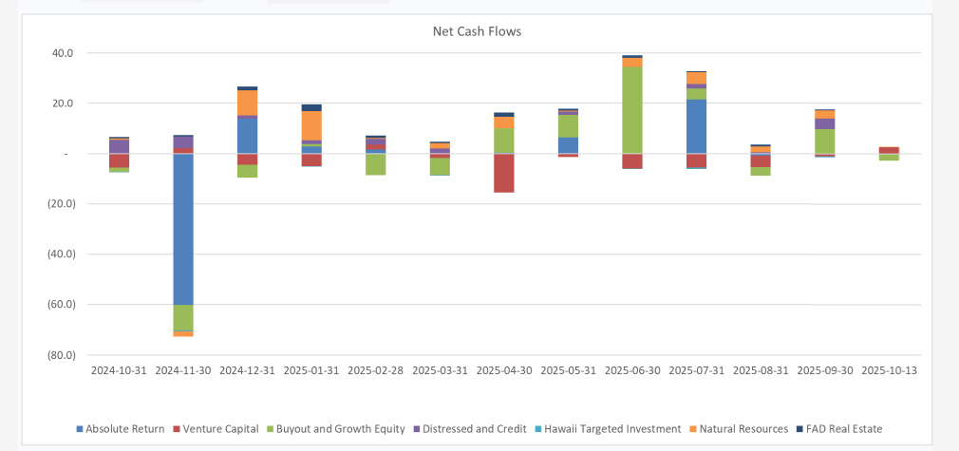
- Capital Call and Distribution Graphs show capital calls and distributions by asset class, using the same interval logic as above.
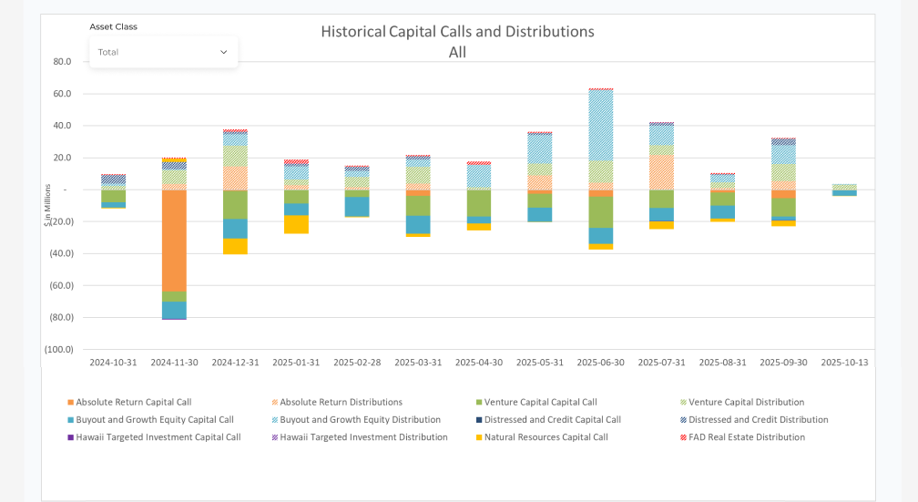
  - A dropdown lets users choose specific asset classes to display; all are shown by default:
  - Venture Capital
  - Buyouts and Growth Equity
- Distressed and Credit
- HTI
  - Real Estate
    - Natural Resources
    - Absolute Return
- All Other

  - A table presents capital calls and distributions as percentages of NAV and distribution, based on selected intervals from the Capital Call and Distribution Graphs.
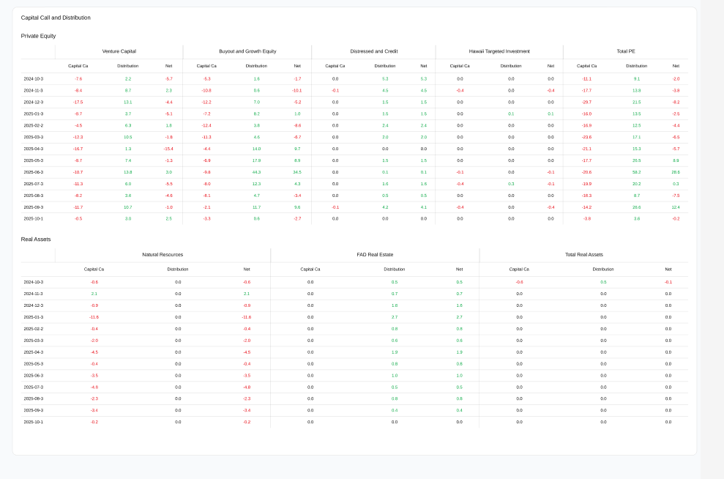
Details Tab:
Core Features:
Overview: The details tab will output the underlying future transactions that comprise the cash forecast. Users will be able to filter by asset class, date, etc. Download to excel feature is available here.
The table will display each individual transaction for the future year
